Applied Science and Technology 416

COURSE SYLLABUS

2016-2017

Instructor: Miss T. Ausman
Room: 252
Contact Email: tausman@wqsb.qc.ca
Homework Homepage: missausman.weebly.com
It is imperative that you check the homework homepage daily. I will assign homework in class, which will then be posted with due dates on the homework page. This website is accessible on your smartphone. In other words, there is no excuse not to be knowledgeable about the homework due dates, even if you are absent for sickness, school-related activities, or family reasons.
Texts and Required Readings
This course uses the following textbook and its associated workbook:
Cyr, M; Forget, D; Verrault, J. (2009). Observatory: The Environment. Saint-Laurent, QC: Éditions du Renouveau Pédagogique, Inc.
Course Materials
A bound notebook for all notes (no looseleaf!). I am happy to provide these free of charge.
Textbook and workbook (provided)
Pens, pencils, ruler
Non-graphical scientific calculator
Course Evaluation and Assessment
You will be evaluated on the following two criteria in this course in each term.
- Practical – 40%
- Theory – 60%
Course Assignments and Weightings
Competency 1 (Practical) includes investigations and activities (70%) and full lab reports (30%).
Competency 2 (Theory) is comprised of assignments (30%), tests (50%) and quizzes (20%).

Course Content:
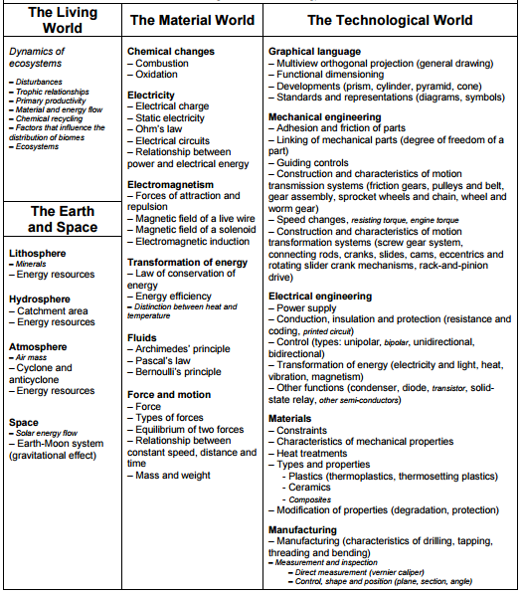
Your final exam will be weighted 50% against your final course mark to reflect your overall mark for Science AST 416.
Missing a Test or Quiz
Tests must be written on the scheduled day. If you know ahead of time that you will be away, alternative arrangements must be made before the test date. Missed tests will be written on your own time at lunch.
Late Policy
All late arrivals will be recorded and detentions are served with the office.
Absences
You are responsible for catching up on class notes and completing any assignments, tests or quizzes for which you were absent (no grade exemptions will be given for missed work). If you are aware of your absence in advance, please let me know.
Class Procedures
We all must respect one another. My foremost request is that you do not talk while I am speaking – whether it is during attendance or when I am at the front of the room speaking to you.
Your responsibilities include all of your materials to every class. Please do not do science work in pen. You need your binder and your texts and homework. You will not be permitted to go to your locker, as per school rules. As well, you must hand in all assignments on time. While I am somewhat flexible about late assignments due to illness or other excused absences, I expect you to see me the day you return from illness, whether we have class that day or not, to get your missed work. You need to be caught up at all times because you will quickly get behind. Assessments not turned in will result in study-hall appointments until I receive the missed work.
Plagiarism
Many students, afraid that their incomplete homework will be checked by me, copy another’s answers at lunch or prior to class. If you do this, it is cheating, and I will give a grade of zero for the assignment and refer you to the administration for disciplinary action. The integrity of everyone’s individual grade is important, especially as this course is needed for both high school graduation and post-secondary admission.
Safety
Safety is paramount in a science laboratory. You must not use any of the equipment jokingly or inappropriately, as I will ask you to leave and you will not be able to finish the work or gain valuable hands-on experience. As well, for labs involving Bunsen burners, chemicals, or power tools, safety goggles, closed-toed shoes, and hair-tied back are mandatory.

I am sure we will have an excellent time in AST 416. Study hard!

